AI Driven Accessible Examination and Assessment System for

Visually Impaired Students

BY: SHREIYA.D

Abstract
Traditional online exams are not accessible for visually impaired students as they depend on reading and mouse clicks. This project proposes an AI-driven accessible examination system using Text-to-Speech (TTS), Speech-to-Text (STT), and NLP voice commands. Admin uploads question paper PDF which is auto-extracted using AI .Students login via voice-enabled authentication (Name + Reg No with STT/TTS) and take the exam completely by voice - questions are read aloud, answers are spoken as "Option A", navigation by saying "Next, Previous, Repeat, Submit". System also has keyboard fallback ensuring 100% inclusivity. No external hardware is required.

Introduction
Education must be inclusive. 2.2 billion people have vision impairment globally. Current exam portals like Google Forms, Moodle fail for blind students. Our system bridges this gap by making the entire exam flow hands-free and ear-driven using Web Speech API and AI PDF parsing. Developed with React + Fast API.

Objective
Main Objective:
To develop a fully inclusive, AI-driven examination system that empowers visually impaired students to write exams independently without a scribe.
Sub-Objectives:
1. Voice-Based Secure Login:
To provide voice-based authentication for blind students using Name and Registration Number. System will use Speech-to-Text (STT) to capture spoken input and Text-to-Speech (TTS) to give audio guidance like "Please say your Registration Number". This ensures login without needing to see or type.
2. AI Automation for Question Paper Creation:
To automate question paper creation via AI PDF extraction. Admin uploads any PDF question paper, backend uses PyMuPDF and AI parsing to automatically extract questions, options (A, B, C, D), and correct answers and stores in database. Saves 90% manual typing time.
3. Complete Hands-Free Examination:
To conduct complete exam using only voice. TTS will read questions and options aloud automatically. STT will capture student answers when student says "Option A", "Option B", etc. No mouse, no keyboard needed.
4. NLP-Based Smart Voice Navigation:
To implement NLP commands for navigation. Student can say "Next" to go next question, "Previous" to go back, "Repeat" to hear question again, and "Submit" to finish exam. System understands natural voice variations.

5. Hardware Independence:
To ensure no external hardware is needed. Entire system works on internal laptop mic and speaker. Also provides keyboard fallback for devices without mic, ensuring 100% accessibility in any college lab.

Problem Statement

Visually impaired students cannot read questions, cannot see options, cannot use mouse. They need a human scribe. No privacy, dependency, and lack of self-confidence. Existing system has no voice navigation, no audio feedback, no accessible login.

Existing System
- Moodle, Google Forms, Black board
- Requires reading screen
- Requires mouse/keyboard precision
- Needs external scribe / screen reader (JAWS) which is costly
- PDF question papers are manually typed again

Disadvantages of of Existing System
- No voice-controllable
- No TTS/STT integration
- Scribe dependency - privacy issue
- Expensive screen readers
- No AI automation for paper creation
- Not usable without hardware assistance

Proposed System - What WE Are Doing

Admin: Uploads PDF -> AI (PyMuPDF) extracts Q&A -> Saves to JSON DB.
Student Login: Enter Name + Reg No -> Can SPEAK name, HEAR instructions via TTS -> Say "Start Exam".
Exam Engine: Auto speaks Q1, options -> Student says "Option A" or "Next" -> TTS confirms -> Auto-

BLOCK DIAGRAM

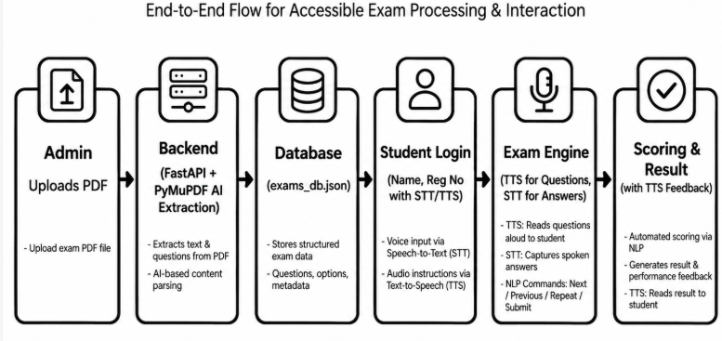

Advantages
- 100% Voice Controlled –
- No scribe needed
- Privacy and Independence for blind students
- AI PDF parsing saves 90% admin time
- Dual Mode: Voice + Keyboard fallback - works without mic also
- No external hardware - uses internal laptop mic/speaker
- Low cost - Uses Web Speech API (free) not paid JAWSNLP based smart navigation
- Software & Hardware Requirements

Software
- Frontend: ReactJS, React-Router, Web Speech API (Speech Recognition, Speech Synthesis)
- Backend: Python Fast API, PyMuPDF (fitz), Uvicorn
- Database: JSON / Local Storage (can be upgraded to MongoDB)Browser
- Google Chrome (best for Speech API)
- IDE: VSCode

Hardware
- Minimum: Any Laptop/PC with internal mic and speaker (No external mic required)
- Recommended: 4GB RAM, i3 Processor

References
- Web Speech API - MDN Docs
- PyMuPDF Documentation
- FastAPI Documentation
- WHO Report on Vision Impairment 2023
- Research Paper: Accessible e-learning for visually impaired - IEEE 2022

